A
anko Technologies Inc.
Safety and Security Solutions

Statement of Qualifications

AANKO (A-an-ko: a Dutch root word meaning: "Arrival at a destination during a journey.") Why follow the beaten path, when you can discover new frontiers at the forefront of your profession? Discover Aanko Technologies Inc., and "Lead the Journey..."™
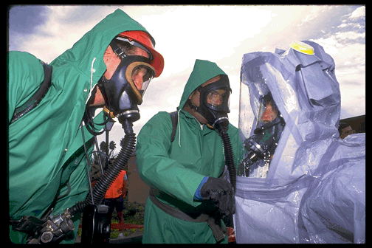

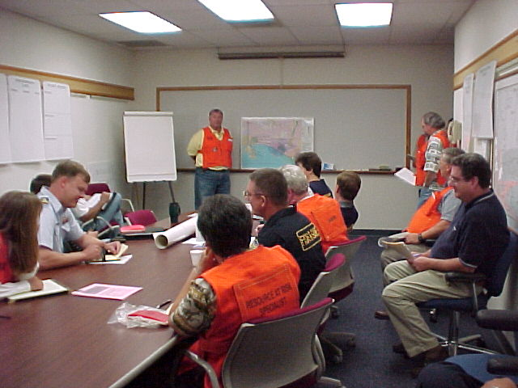
Global Services

Risk Assessments
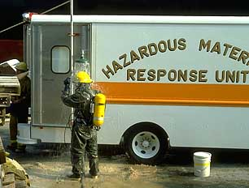
Safety & Security Consulting
Cyber-Physical Systems Consulting
Emergency Management Consulting
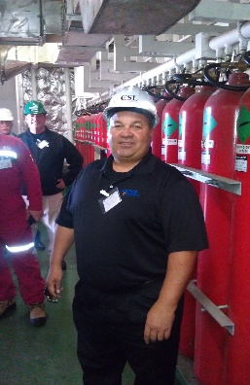
Engineering Studies
Training

607 Elmira Rd, Suite 191
Vacaville, CA 95687
Ph: 1-866-968-7478 (Toll Free)
Ph: 415-408-8004 Fax: 415-520-5330
www.aanko.com

Introduction

Aanko Technologies is a California Certified Minority and Veteran-owned Small Business Enterprise providing safety and security solutions since the summer of 1997. We have offices in Northern California, Los Angeles, and Seattle, Washington.

We work with clients to analyze their Risk. Our assessments determine the where and why of investing valuable resources to protect their interests, before rolling out safety and security projects.

We are not aligned with any one product or methodology. We create solutions from best practices to promote your revenue generation and employee productivity, instead of selling a specific product that can din your funds and may not further your strategic objectives.

Our Mission
Assist clients to Lead the Journey…™ at the forefront of their profession, by providing exceptional Safety and Security Consulting and Training Services.

The Aanko team comes from a broad multicultural background and includes over 160 years of combined experience with risk assessment, safety, cyber and physical security, and emergency management expertise, led by CEO Steve Longoria, the only person ever officially selected as the top professional in three different career classifications for the Department of Defense:

- #1 Department of Defense Antiterrorism Manager
- #1 U.S. Air Force Security Specialist
- #1 U.S. Air Force Safety Manager

Our dedicated team uses proven methodologies such as systems safety processes, industrial safety risk assessments, and cyber-physical security assessments, as well as emerging technologies to provide successful resolutions to client needs.

Quality / Environmental Management Systems

The Aanko team is familiar with the International Organization of Standards (ISO) implementing an effective Quality Management System (QMS) and Environmental Management System (EMS) to comply with regulatory, industry, and customer quality requirements. The QMS/EMS applies to all engineering activities that affect the quality of services furnished by Huron. It also defines the basic requirements of the client service contracts and serves as a commitment to our clients. Our QMS/EMS incorporates quality planning and provides a basis for managing project activities allowing us to monitor processes for continual improvement and overall cost control. The QMS/EMS activities are documented in accordance with written manuals, procedures, instructions, specifications, and drawings that contain appropriate criteria for determining whether prescribed activities have been satisfactorily accomplished. The following outlines the basic principles:

• Accuracy
• Constructability
• Cost Control
• Drawing Clarity
• Milestones
• Thoroughness of Detail

We have assisted Fortune 500 companies, municipalities, healthcare facilities, police agencies, fire departments, energy, chemical and aviation industries, universities and Ports in conducting risk assessments and developing emergency response plans, terrorism countermeasures, injury and illness prevention plans, hazardous materials business plans, and employee safety and security training programs.

Our efforts have helped to increase client safety and security while recovering over 50 million dollars in client corporate assets.

By partnering with Aanko Technologies Inc., your business has access to some of the best security and counterterrorism experts, emergency managers and safety engineers, and cutting-edge information technologies, providing quantifiable returns on your investment from the start.

We believe concepts and technologies implemented without a comprehensive plan is relevant to chaos. To ensure consultation derives the most cost effective, employee-involved benefit for clients, we have identified seven core indicators in our SUCCESS™ pyramid.

Sustainment is our ability to deliver sustained strategic concepts. These concepts become the foundation blocks for short and long-range plans.
Sustainment
Uniformity
Customer Focus
Creativity
Empowerment
Stability
Strength
Aanko Technologies Inc.’s Success Pyramid©

Uniformity is the merging of your key personnel with our “outside” view consultants to form a decision-making team. This ensures all facets of the safety and security environment are identified and analyzed.

Customer Focus is our understanding of core products or services to be delivered. This drives the identification, selection and level of shared risk taken to arrive at the project concept.

Creativity involves team openness, sharing and discussion of innovative ideas. We value each team member’s role in analyzing safety and security data and in creation of ongoing processes.

Empowerment identifies the knowledge each person brings to the team and provides the tools and authority necessary to meet their responsible tasks. This allows everyone to grow and excel while meeting team objectives.

Stability is provided by our client/consultant partnership to mentor, coach and advise teams to support safety and security process improvements for complete organization development.

Strength is gained by sharing knowledge among teams to classify project results, creating a learning organization that turns identified processes into action. Through a safe and secure environment, you can successfully position your organization to effectively lead your competition, while increasing revenue and productivity.

We customize our services to maximize your organizational strengths. This allows strategies and resources to work in practical, economical and powerful new ways to spur innovation and create new or expanded capabilities to increase revenue and maximize productivity.

At Aanko Technologies Inc., we plan, partner and perform with the client’s result in mind. We plan by using the concept of Understanding by Design, which is a framework for visualizing the client’s requested outcome with them and gaining insight to the organization’s ideas, people, and situations. We then analyze potential obstacles to success and partner with the client to resolve bottlenecks.

Through Consultation, our experts identify safety and security gaps and provide solutions to maximize an organization’s human and capitol resources.

In Safety, we perform a gamut of state and federal regulatory compliance consultation and training. Clients include organizations with several employees to several thousand, allowing us to offer expertise to clients and communities in a manner that best suits their needs.

In Security, our team includes cyber and physical system experts, with over 36 years of vulnerability assessment, counterterrorism, threat management and intrusion detection systems expertise.

Our Emergency Management assistance includes designing, developing, and implementing plans and programs that result in meaningful pre-disaster and emergency response actions by community and business personnel. Comprehensive drills and exercises are also designed and facilitated, as they are the most direct means of assessing client emergency plans and procedures and demonstrating the readiness of internal organization or external mutual aid responders.

Through Training, we assist organizations in fully developing their people for increased protection, awareness, and revenue generation.

We have Information Technology and Cyber-Security experts to integrate client processes for maximum asset protection and value. This expertise includes cybercrime identification, computer forensics, and network and cloud security with CFE, CISSP and CISA backgrounds.

Our team enhances an organization’s development through additional human resources training to promote full safety and security prevention and protection for public and private sector clients.

The partial list of completed projects and reference letters identified in the next pages provide measures of Aanko Technologies Inc.’s, performance through planning and partnering with clients over a sustained period of success.

By carefully defining each client’s need relative to their mission, we continue to identify and overcome obstacles to achieve client goals. Achievements that help our clients “Lead The Journey…™” at the forefront of their profession.

Selected Representative Projects

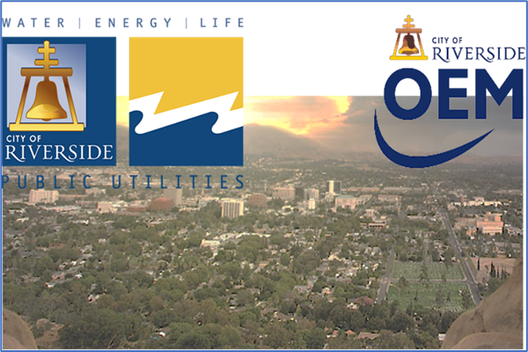
City of Riverside and Riverside Public Utilities Emergency Management Project, 2021 | Riverside, California |Aanko was selected by the City and Utility for an emergency management project to develop 32 emergency plans and Annexes, including a Continuity Plan and Pandemic Plan in 31 days due to a sunsetting grant. The Riverside Public Utilities provides electric, water and wastewater service to over 300,000 residents. The Aanko team created these comprehensive NIMS and ICS-compliant documents within this timeframe, and also ensured a structured review of the draft documents by stakeholders from the City and Utility. The final documents included a City-Wide Emergency Operations Plan, support annexes for Public Works & Engineering, Energy & Utilities and Cross Sector Business & Critical Infrastructure, as well as a Continuity of Operations Plan, a Pandemic Plan, and Community Lifelines.

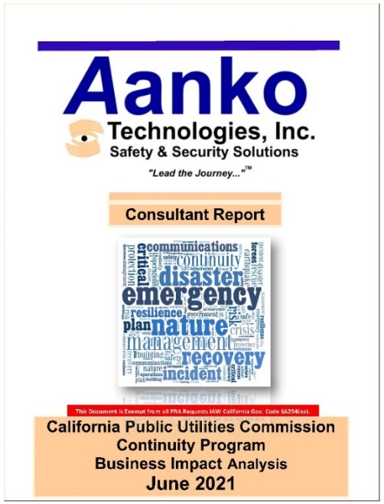
California Public Utilities Commission (CPUC) Business Continuity Program | California Statewide | Aanko was selected by the CPUC in 2021 to create a new Business Continuity Program from the ground up. The CPUC regulates all privately owned electric, natural gas, telecommunications, water, railroad, rail transit, and passenger transportation companies in the state. This continuity process involved development of a comprehensive review of all business processes for Mission Essential Function validation across the entire state of California and a detailed Business Impact Analysis. Creation of a Business Continuity Program Standard, Business Continuity Executive Steering Committee Charter, and stand up of a new Business Continuity Office followed. Business Resumption Plans and a new Enterprise-Wide (statewide) Continuity of Operations Plan will be completed in 2022.

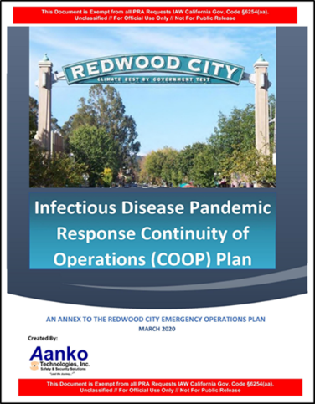
City and Port of Redwood City Facility Security Plan and Emergency Operations Plan – Redwood, CA (2003–Present)
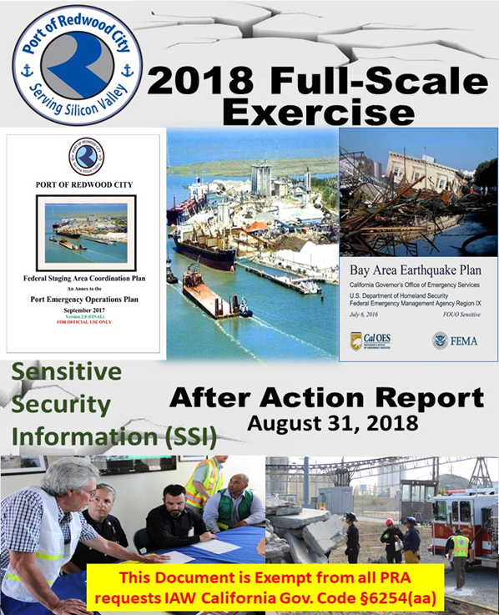
Aanko was selected to complete a series of comprehensive safety and security assessments for the Port and the City, including an Emergency Operations Plan (EOP) under the National Incident Management System. Activities involved initiating and evaluating drills and exercises against the plan, facilitating EOP training for City and Port workers, including fire, police, and public works departments and developing a capabilities assessment. Most recently, Aanko developed a Pandemic-Infectious Disease Continuity of Operations Response Plan 2020, an Annex to the Redwood City Emergency Operations Plan.
Tasks have included:
- Develop City and Port EOPs
- Develop FEMA all-hazards Incident Command System (ICS) position checklists for field and Emergency Operations Center
- Develop City Earthquake and Flood Response Annexes to EOP
- Train over 700 City staff in ICS functions
- Facilitate Full Functional Exercises 2005–2019 as site exercise designers, controllers, and evaluators
- Conduct Cyber-resilient Online Exercise Workshops in 2020 due to COVID-19
- Develop Port Business Continuity Plan, Maritime Facility Security Assessment & Plan, Strategic Security Plan, and Federal Staging Area Pre-Activation Plan in support of the Bay Area. Catastrophic Earthquake Plan from 2005–2020

Employment Development Department (EDD) | California (2019–2021)
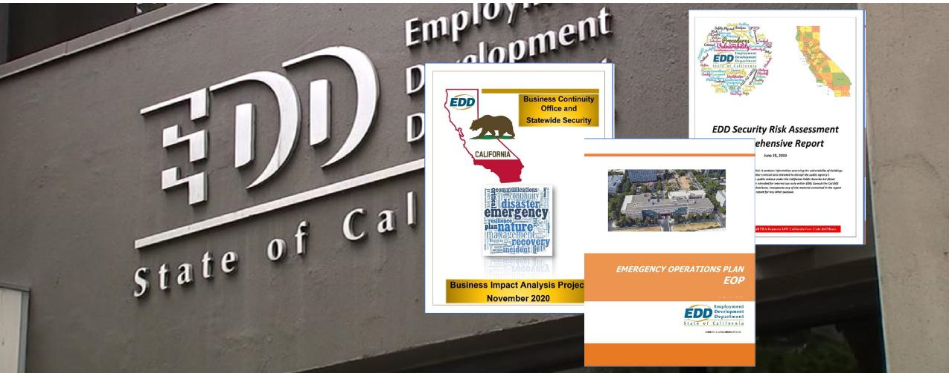
In 2019, Aanko was selected to conduct 21 statewide threat and vulnerability assessments (TVAs) to identify security risks against EDD personnel and assets.
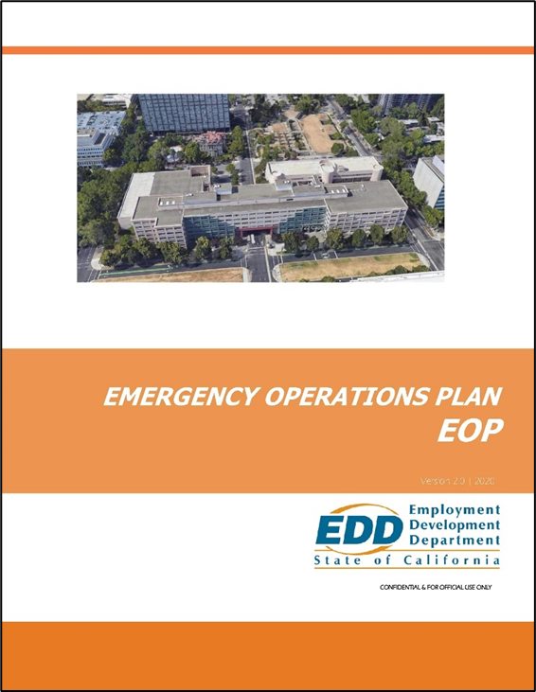
In 2020, Aanko conducted a BIA (Business Impact Analysis) for the entire EDD BCP.
Within this project, Aanko updated EDD’s Enterprise-level Continuity of Operations Plan (COOP) and, revised all 15 Branch and Division Business Resumption Plans (BRPs), including re-validation of all Mission Essential Functions and Mission Essential Services (MEF/MES); created an Statewide Crisis Communication Plan (CCP) and Emergency Operations Plan (EOP); and provided business continuity and Homeland Security Exercise and Evaluation Program (HSEEP) training to all Business Continuity Office (BCO) staff.
This training included a Train-the-Trainer component so the BCO could continue training additional EDD personnel throughout the state for sustained business resilience and to conduct their own HSEEP Tabletop Exercises throughout the state (Aanko personnel are certified HSEEP Train-the-Trainers).

Franchise Tax Board (FTB) | California (2002–2021)
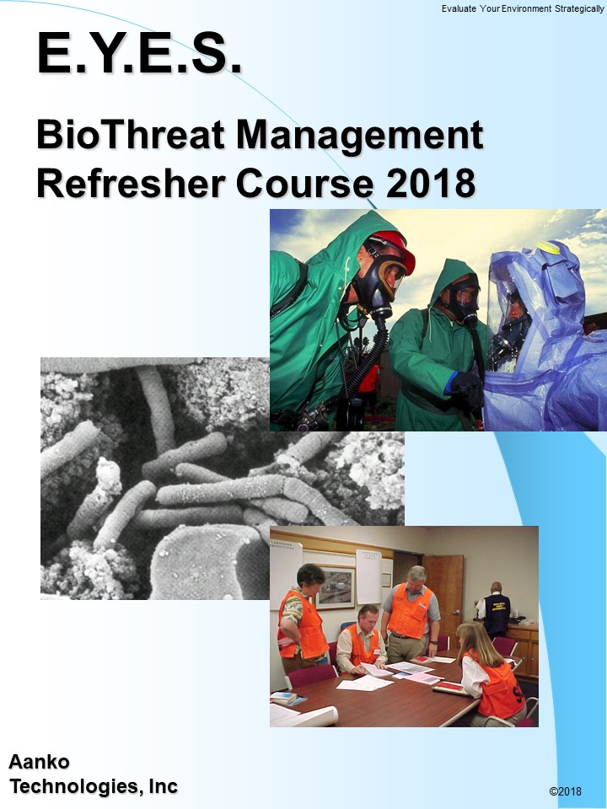
Aanko has consulted with the State of California Franchise Tax Board on security and emergency management since 2002. This has included comprehensive facility-wide operational assessments, to include environmental (air quality) and infrastructure threats (HVAC & security access).

Additionally, Aanko assisted health & safety groups in identification of staging and deployment areas, development of engineering controls for outside air isolation, and development of security and emergency plans to identify and prepare facilities for mass casualty operations for the over 8000 employees. Ongoing annual training since 2002, including in 2020 and 2021 during COVID-19, has included response and recovery from biological and chemical threats, business continuity, emergency planning and employee awareness.

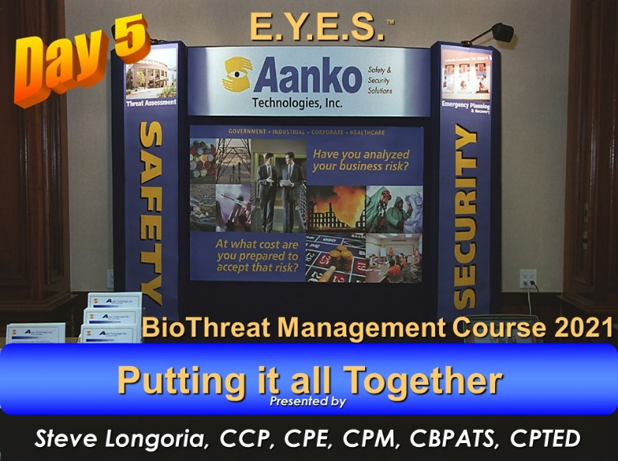
In 2018, Aanko completed a $200 million dollar security design update for the FTB as the Subject Matter Experts for California State Department of General Services.

This included development of site and facility-wide security systems standards, and complete redesign of the Security & Emergency Command Center (SECC).

California Governor’s Office of Emergency Services (CalOES) | California (2006–2021)

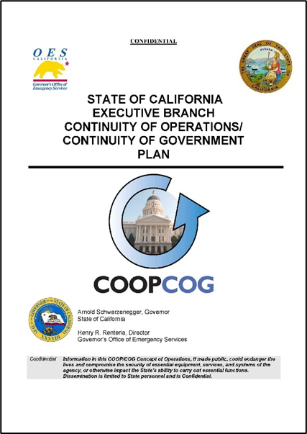
In 2006, Aanko was selected by CalOES to develop the first-ever State Executive Branch COOP/COG Plan, to include all 93 state agencies.

Aanko led all 93 state agencies in addressing ADA and Access and Functional Needs requirements and provided Continuity Training to internal CalOES staff.

Aanko has continued to provide consultation to CalOES, including being part of the core CalOES Golden Guardian Statewide Exercise Team from 2005-2015.

Aanko continues to provide consultation to the State, most recently as part of a CalOES contingent to create situational awareness Common Operating Pictures through the state’s Maritime Domain.

City of South San Francisco | California (2014-2016)

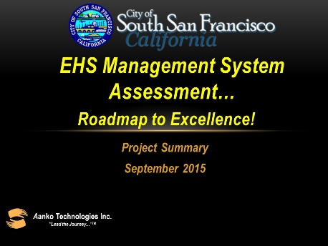
For South San Francisco, Aanko assessed the City EHS Management System, so that it could integrate with the emergency management program led by the City Fire Department and its Emergency Service Manager to give the city a tool for systematically evaluating the current effectiveness and efficiency of its EHS Management System, and to provide a roadmap for revamping the system toward a continuous improvement cycle.

The Assessment focused on the current EHS foundation within the City, and the needs of the City to re-invigorate EHS at all levels in a quest toward a world-class EHS Management System that could integrate with Emergency Preparedness. The project provided city leadership an evaluation of every aspect of the EHS management system within the city’s operating departments, including indoor and field work site air sampling protocols.

Aanko developed a 3 and 5-year EHS system management improvement road map, designed to improve organizational EHS culture, define EHS program improvements, and lower the city’s injury rate, and coordinated all processes with the City Emergency Service Manager.

City of Mountain View | California (2009-2012)
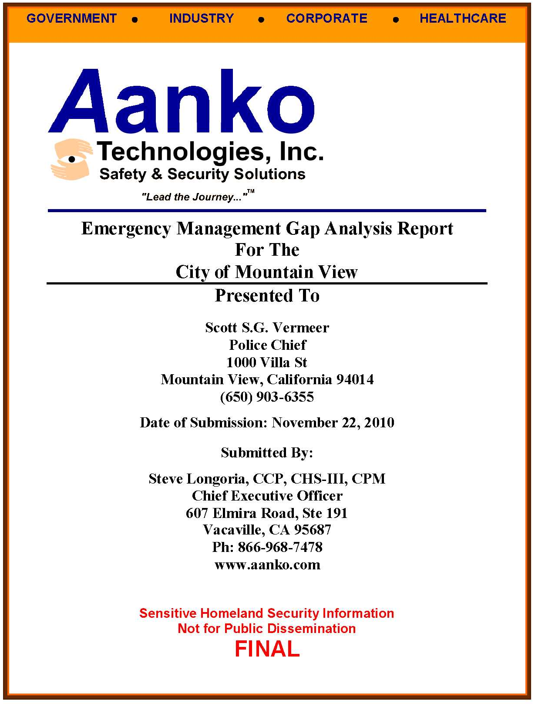
Aanko was selected to complete an emergency management gap analysis for the entire city to determine existing and recommended plans processes and procedures for preparedness, response and recovery from natural and man-made disasters that could impact the city.

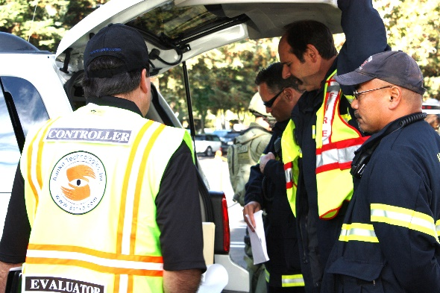
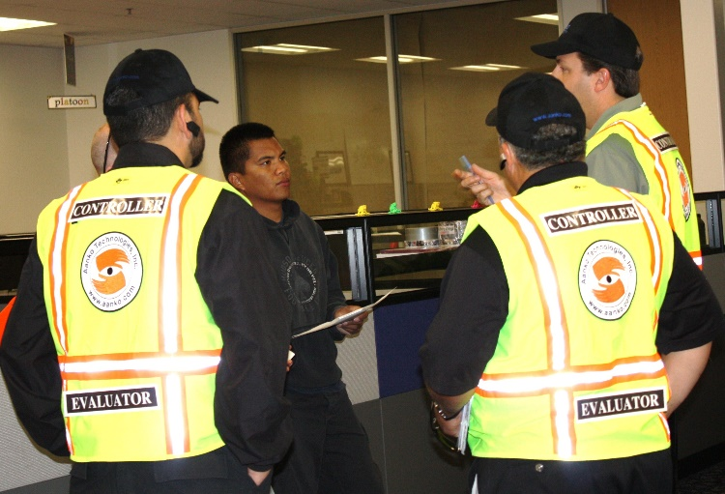
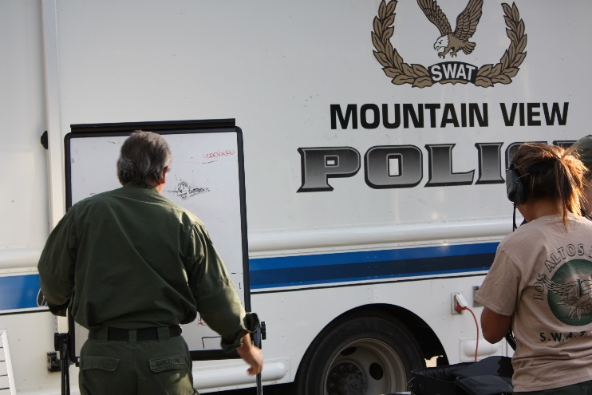
Aanko also provided exercise design and facilitation for the SWAT Operational Exercise in coordination and integration with the cities of Los Altos, Sunnyvale, Palo Alto, and Google Inc., resulting in a comprehensive SWAT Hostage and Active Shooter Exercise facilitated by Aanko at the Mt View Googleplex Campus with over 200 regional SWAT and fire department personnel integrated with Google security forces. The current Police Chief, Chris Hsiung, was the Deputy Chief at the time and is aware of our work.

California Department of Technology | California (2016-2021)

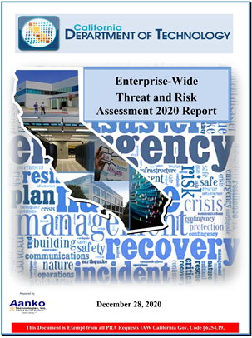
Aanko conduct the 2016, 2018, and 2020 CDT Threat and Risk and assessments.

Assessment scope included continuity. and emergency management, and human and capital resources risk. Aanko reviewed all emergency management and business continuity programs, validated risk and provided comprehensive reports to senior state leadership, including the State Chief Information Officer and Governors Brown and Newsome. See Appendix 1 for a Letter of Reference from the CDT on Aanko’s work products.

Most of this work is security classified.

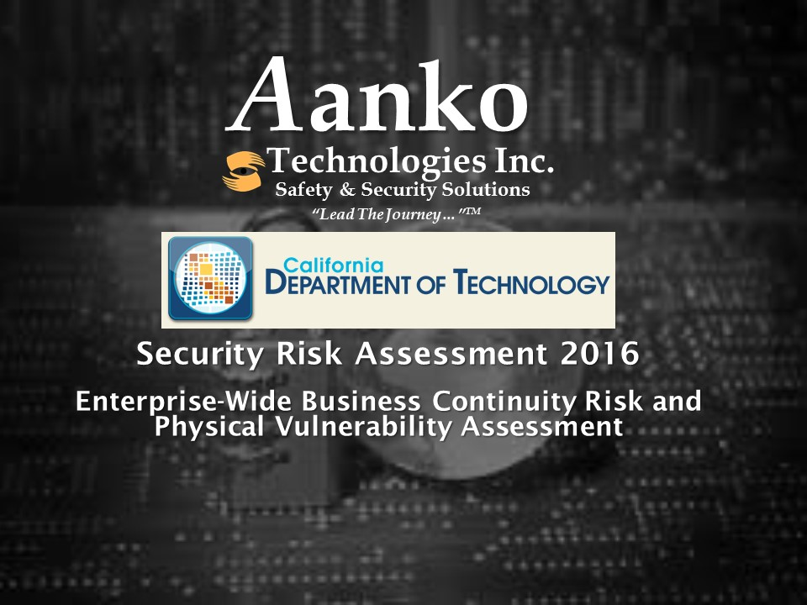

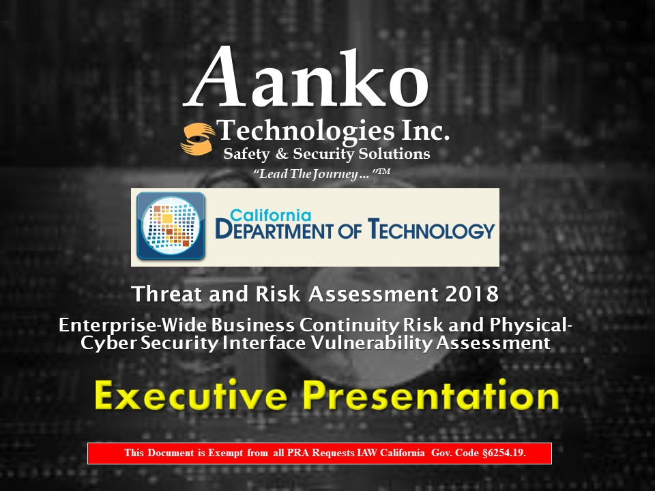

San Bernardino County | California (2016-2020)

Aanko provided on-call security and emergency management services for San Bernardino County in all phases of integrated Emergency Management; mitigation, preparedness, and response and recovery after the Dec 1, 2015 terrorist attacks.

The team conducted site, building, physical, and operational security assessments, and facility emergency evacuation plans updates. The team was also selected to create a new county-wide security awareness program after the December 1, 2015 terrorist attacks.
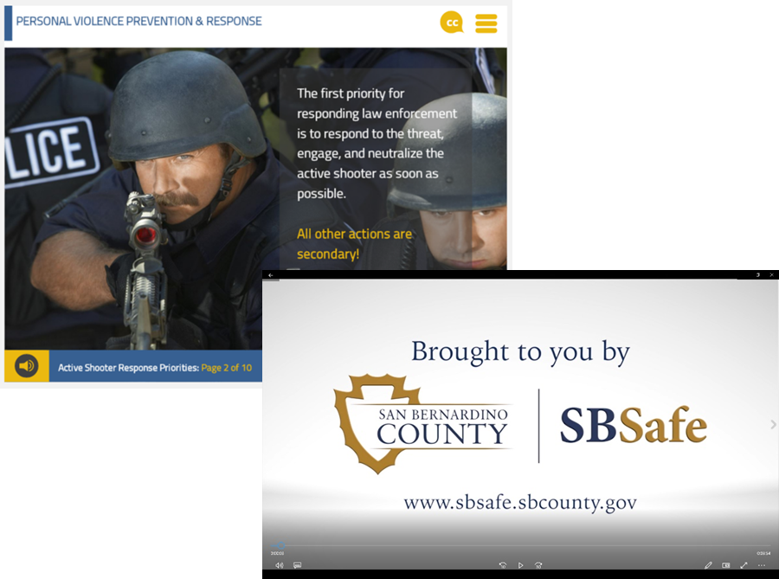
The “SBSafe” program included classroom and web-based E-learning modules on workplace violence, active shooter, and customer and co-worker de-escalation training for over 28,000 county workers.

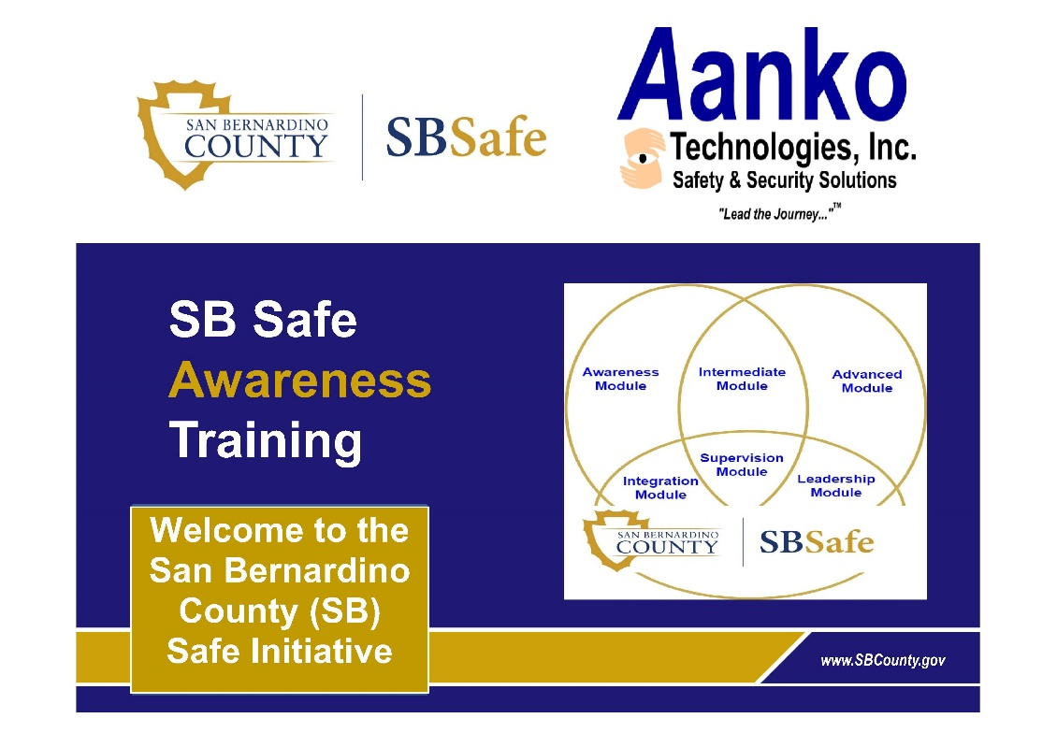

California Energy Commission | California (2013-2020)

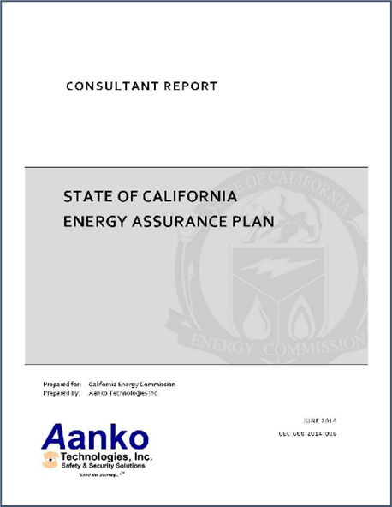
Aanko was selected to develop the state Energy Assurance Plan as required by the US Department of Energy. Processes included energy assurance planning with cyber and physical system interface issues, engagement of statewide energy partners, Homeland Security Exercise and Evaluation Program (HSEEP) seminars, tabletop drills and full-scale exercises from HSEEP-certified Aanko staff to test energy emergency response capabilities. As part of the project Aanko visited multiple sites throughout the state to determine existing capabilities and Critical infrastructure interdependencies. Aanko then worked with industry partners and the CEC to develop Response actions oil, gas and electrical suppliers and for renewable energy portfolios including wind, solar, biomass, hydro and geothermal power generation. Aanko also validated the roles and the level of responsibility of all state agencies charged with responding to energy emergencies and validated energy supply systems across the state as well as inter-state supply chain relationships.

Contra Costa County | California (2004-2009)

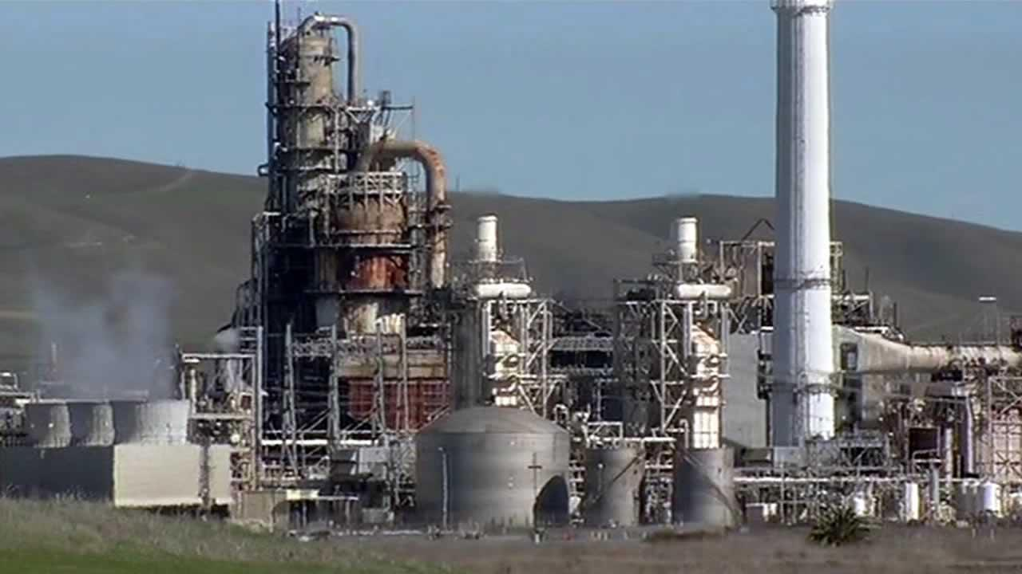
Aanko was selected by the Contra Costa County Homeland Security Unit (HSU) as part of their public-private partnership to assist the HSU and Office of Emergency Services in conducting risk assessments for over 200 identified critical infrastructure facilities county-wide, including petrochemical, government, and public use facilities. The quantitative risk assessments that considered the dependence between hazard potential and associated safeguards allowed the team to identify and rank total risk. Classified assessment results were used to update safety systems and emergency response plans, and to prioritize risk mitigation strategies and budgets throughout the county.

Caltrans | California (2009-2012)

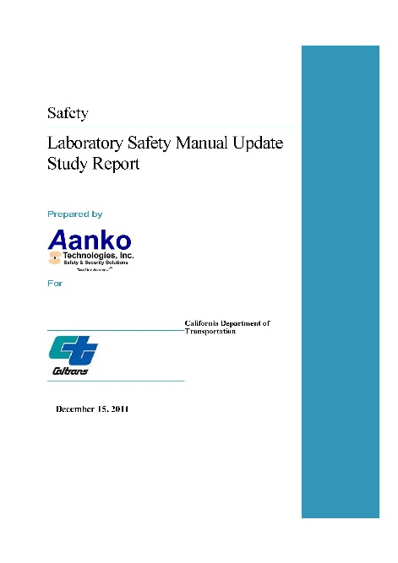
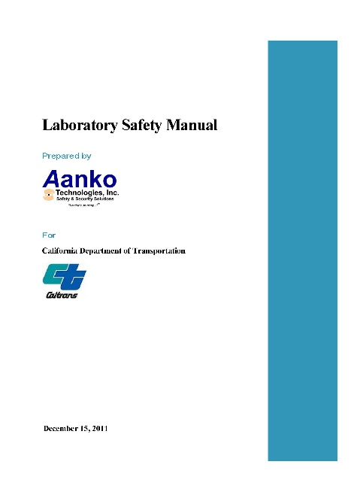
Aanko was tasked by Caltrans to conduct risk assessments at District soils and materials testing laboratories throughout the state to develop a comprehensive laboratory safety network that was previously obsolete to ensure the state was in compliance with Federal Highway Administration and American Association of State Highway and Transportation Officials (AASHTO) requirements. After site assessments and the study were completed, Aanko developed a comprehensive Laboratory Safety manual for use by Caltrans laboratories throughout the state.

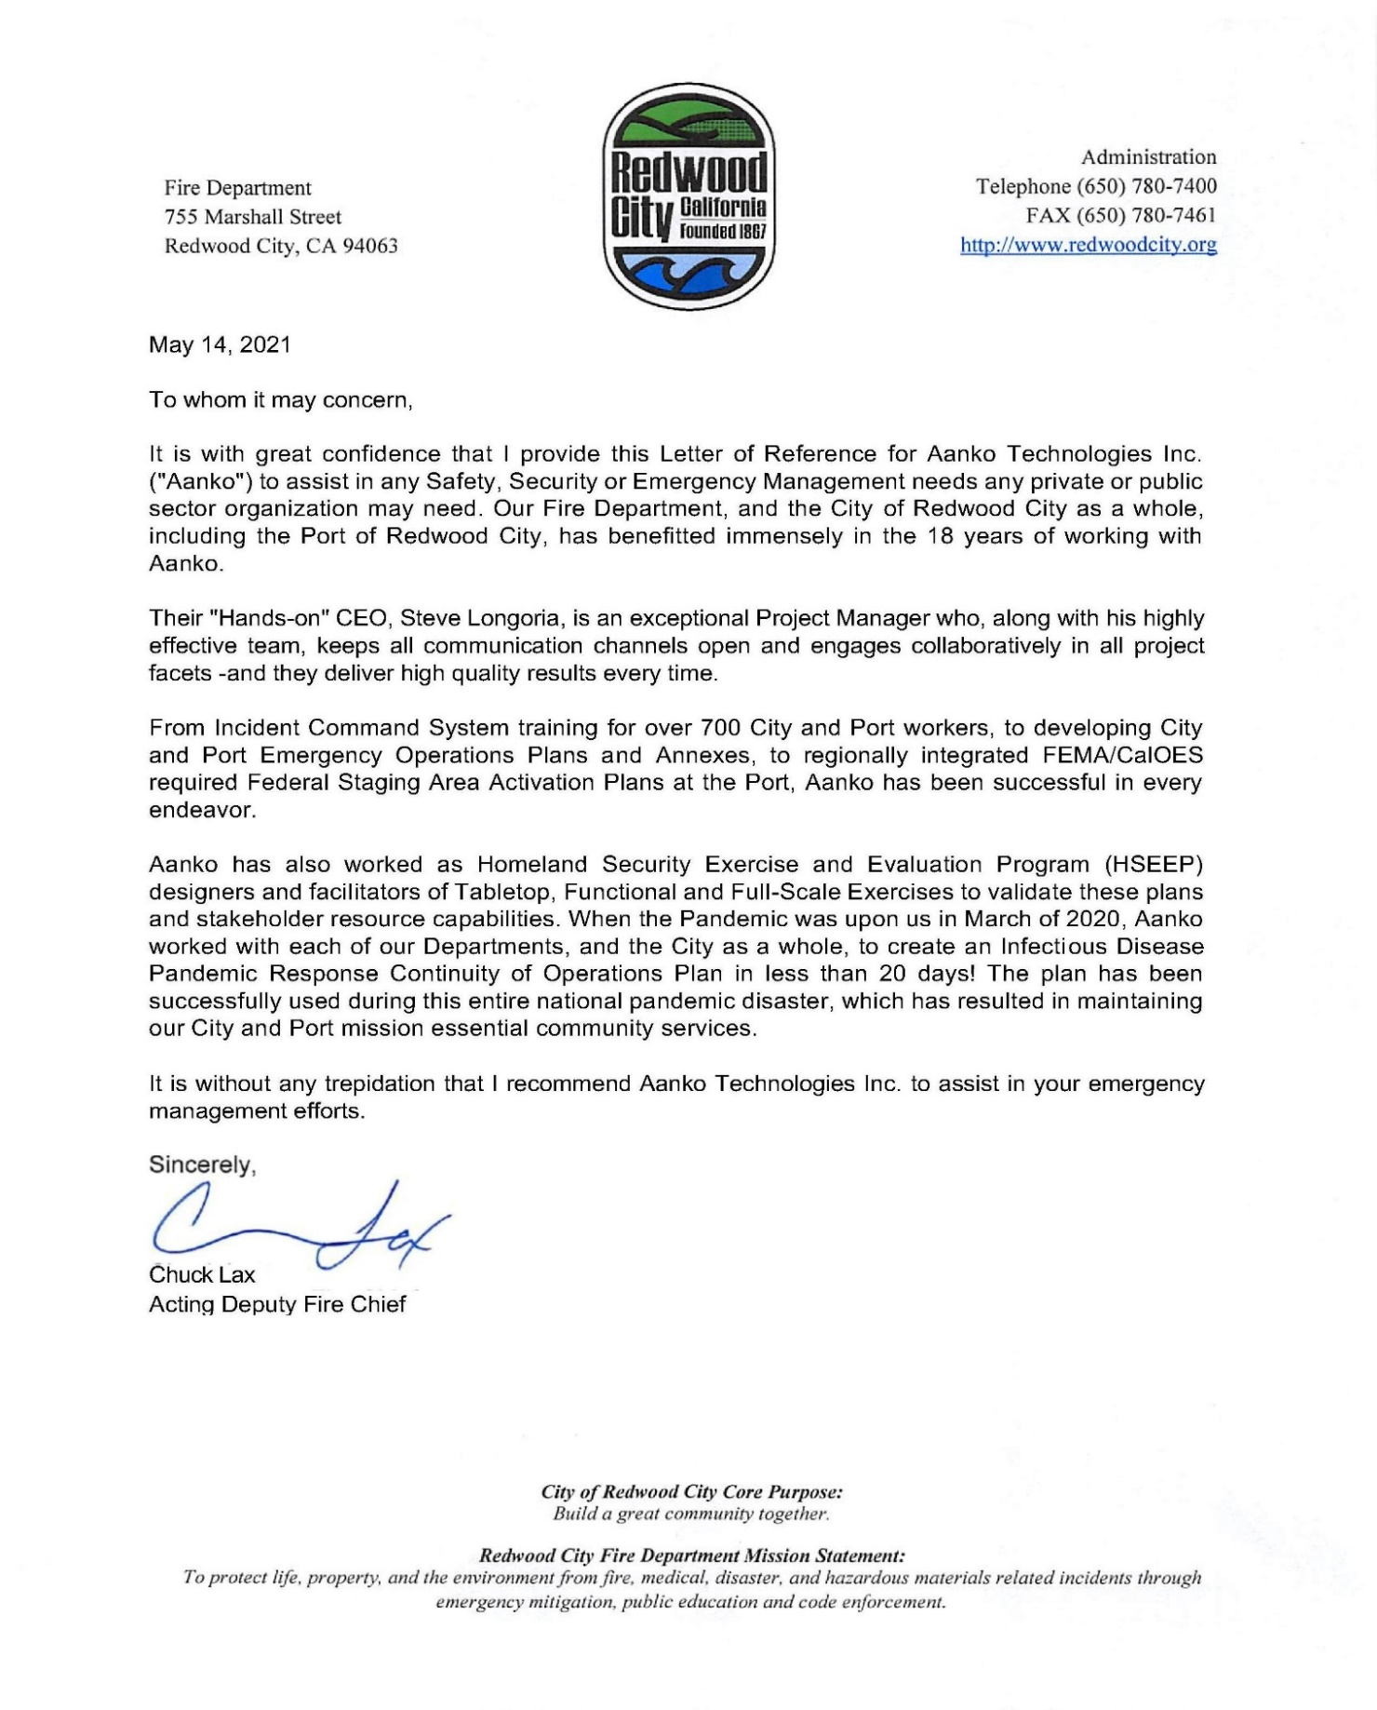
Selected Letters of Reference

